SUPPLEMENTAL MATERIAL
Switchable hidden spin polarization and negative poisson’s ratio in two-dimensional antiferroelectric wurtzite crystals
Zhuang Ma^{1,‡}, Jingwen Jiang^{1,‡}, Gui Wang¹, Peng Zhang¹, Yiling Sun¹, Zhengfang Qian¹, Jiaxin Zheng², Wen Xiong³, Fei Wang⁴, Xiuwen Zhang^{1,5}, and Pu Huang^{1,*}
¹Key Laboratory of Optoelectronic Devices and Systems of Ministry of Education and Guangdong Province, College of Physics and Optoelectronic Engineering, Shenzhen University, Shenzhen, 518060, China
²School of Advanced Materials, Peking University, Shenzhen Graduate School, Shenzhen, 518055, China
³Chongqing Institute of Green and Intelligent Technology, Chinese Academy of Sciences, Chongqing, 400714, China
⁴School of Physics and Microelectronics, Zhengzhou University, Zhengzhou, 450001, China
Email: arvin_huang@szu.edu.cn

‡These authors contributed equally to this work
⁵Current address: Renewable and Sustainable Energy Institute, University of Colorado, Boulder, Colorado 80309, USA

Methods
Electronic structure calculation: The electronic properties of 2D antiferroelectric (AFE) wz crystals were calculated within the framework of density functional theory (DFT)^{[1]} by employing the Vienna ab initio simulation package (VASP)^{[2, 3]}. The projector augmented wave (PAW) potential method was used to describe electron–core interactions. The electron exchange-correlation was treated with the generalized gradient approximation (GGA) of Perdew–Burke–Ernzerhof (PBE)^{[4]}. The cut-off energy was set to 500 eV. The structures were fully optimized until the force and maximum energy of each atom were no more than 0.001 eV/Å and 10⁻⁶ eV. We choose the Γ-centered k-point mesh of 5×5×1 for the ground state calculations. A vacuum space of more than 20 Å was included along the direction perpendicular to ab-plane to avoid mirror interactions for each case. The spin-orbit coupling (SOC) effect was taken into account in electronic structure calculations. The Heyd-Scuseria-Ernzerhof hybrid functional method (HSE06)^{[5, 6]} was used to correct the band gap values and verify spin splitting magnitude for the 2D AFE wz materials. The transition pathway between AFE and centrosymmetric (CS) phases was obtained by using the climbing nudged elastic band (cNEB) method^{[7]}, during which the crystal symmetry and band structure evolution of every image was carefully depicted. To obtain the most stable configuration for the interlayer stacking pattern of AFE, the bottom layer of the bilayer FE was fixed and the upper layer was moved freely in the form of a 2D dense grid mesh, which includes all the possible stacking scenarios for the system. As shown in Fig. S1(a-b), the step size of the active layer gliding within the bilayer was set as a/(n) (a is the lattice constant, n is the number of copies (10)) along the a or b direction, which forms a square potential surface and yields a total of 100 stacking structures. This approach fully optimized the interlayer distance and intralayer atomic position of the bilayer structure, so that the interlayer sliding could be determined more realistically. Similarly, the relative potential energy surfaces for the van der Waals sliding situation (CS phases) along different directions were plotted in Fig. S1(c-d). We used the LOBSTER package^{[8]} to evaluate the bonding interaction of the orbital wavefunction. The crystal structures were visualized through VESTA software^{[9]}. The orientation-dependent Young’s modulus Y(θ) and Poisson’s ratio ν(θ) of the 2D wz AFE materials for the in-plane angle θ were calculated by the formula
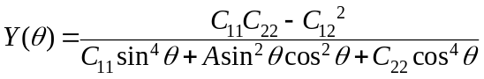 (1)
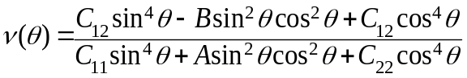 (2)
where four independent elastic constants (C₁₁, C₁₂, C₂₂, and C₆₆) exist in the 2D AFE structure. A=(C₁₁C₂₂-C₁₂²)/C₆₆-2C₁₂ and B=C₁₁+C₂₂–(C₁₁C₂₂-C₁₂²)/C₆₆, as implemented in VASPKIT code^{[10]}.

Thermodynamic and kinetic stability assessment: The thermal stability of all 2D AFE wz crystals was evaluated via ab initio molecular dynamics (AIMD) simulations. The AIMD simulations were performed for 9 ps, and the time step was set to 3 fs with NVT ensemble using the Nosé-Hoover method^{[11]} to control the temperature. A 3×3×1 supercell containing 144 atoms is adopted to reduce the constraint of the periodic boundary condition. To confirm the dynamical stability of AFE configurations, we further derived phonon dispersion curves using the finite-displacement approach as implemented in the Phonopy code^{[12]}. Usually, the limited supercell used to calculate the phonon could cause numerical inaccuracy for some 2D systems, e.g. the ~0.1 THz minor imaginary frequency displayed around the Γ point. This slight spoon-shaped characteristic is caused by the flexural acoustic modes, which is a common phenomenon in 2D materials (e.g., FeB₂^{[13]} and NbB^{[14]} etc) and is not considered dynamically unstable.

Table S1: Currently available 2D AFE materials with FC, NPR, band gaps and band structure properties.
Compounds | AFE | FC | NPR | gap (eV) | direct/indirect | Reference
Bi monolayer | Y | N | N | metal | / | Ref^{[15]}
In₂S₃ | Y | N | N | 1.0 | indirect | Ref^{[16]}
unzipped graphene oxide | Y | N | N | / | / | Ref^{[17]}
bilayer α-In₂Se₃ | Y | N | N | 0.69  1.278 | indirect | Ref^{[18, 19]}
β’-In₂Se₃ | Y | Y | N | 0.8 | indirect | Ref^{[20]}
NbOX₂ (X=Cl, Br, I) | Y | N | N | 1.84~3.99 | indirect | Ref^{[21]}
α-GeSe | Y | N | N | / | / | Ref^{[22]}
(i-BA)₂CsPb₂Br₇ | Y | N | N | / | / | Ref^{[23]}
(BA)₂(EA)₂Pb₃I₁₀ (1), | Y | N | N | / | / | Ref^{[24]}
(isopentylammonium)₂CsPb₂Br₇ | Y | N | N | / | / | Ref^{[25]}
quintuple-layer (QL) LiBiO₂ | Y | N | N | 2.324 | indirect | Ref^{[26]}
Ga₂O₃ | Y | N | N | ~2.5 | indirect | Ref^{[27]}
CrO₃ | Y | N | N | 1.27 | indirect | Ref^{[28]}
CuInP₂Se₆ | Y | N | N | / | / | Ref^{[29]}

Table S2: The lattice mismatch calculated by using the formula ƞ=$\frac{(a_{1}-a_{2})}{a_{2}}×100\%$, where a₁, a₂ and b₁, b₂ are the lattice constants of the corresponding 2D AFE wz crystal and substrate supercells, respectively (a% and b% represents the mismatch directional along a and b axes).
a% (m$×$n)  b% (m$×$n) | Graphene (2.47 Å) | 2H-MoS₂ (3.18 Å) | h-BN (2.51 Å)
ZnS | -0.3 (a₁$×$3a₂)  2.1 (4b₁$×$6$\sqrt{3}$b₂) | -0.4 (3a₁$×$7a₂)  -4.9 (4b₁$×$5$\sqrt{3}$b₂) | -1.9 (a₁$×$3a₂)  0.4 (2b₁$×$3$\sqrt{3}$b₂)
ZnSe | 3.0 (a₁$×$3a₂)  -4.5 (3b₁$×$5$\sqrt{3}$b₂) | -4.0 (2a₁$×$5a₂)  -1.1 (4b₁$×$5$\sqrt{3}$b₂) | 1.3 (a₁$×$3a₂)  4.4 (2b₁$×$3$\sqrt{3}$b₂)
ZnTe | -1.4 (3a₁$×$10a₂)  1.8 (3b₁$×$5$\sqrt{3}$b₂) | 2.1 (2a₁$×$5a₂)  -1.1 (3b₁$×$4$\sqrt{3}$b₂) | 7.8 (2a₁$×$6a₂)  0.2 (3b₁$×$5$\sqrt{3}$b₂)
CdS | -2.0 (4a₁$×$12a₂)  -1.0 (3b₁$×$5$\sqrt{3}$b₂) | -1.0 (2a₁$×$5a₂)  -3.9 (3b₁$×$4$\sqrt{3}$b₂) | 4.5 (a₁$×$3a₂)  -2.6 (3b₁$×$5$\sqrt{3}$b₂)
CdSe | 7.7 (a₁$×$3a₂)  1.7 (3b₁$×$5$\sqrt{3}$b₂) | 0.4 (2a₁$×$5a₂)  -1.3 (3b₁$×$4$\sqrt{3}$b₂) | 6.0 (a₁$×$3a₂)  0.1 (3b₁$×$5$\sqrt{3}$b₂)
CdTe | -1.9 (3a₁$×$10a₂)  3.1 (3b₁$×$5$\sqrt{3}$b₂) | 1.6 (2a₁$×$5a₂)  1.7 (3b₁$×$4$\sqrt{3}$b₂) | 7.3 (a₁$×$3a₂)  3.1 (3b₁$×$5$\sqrt{3}$b₂)

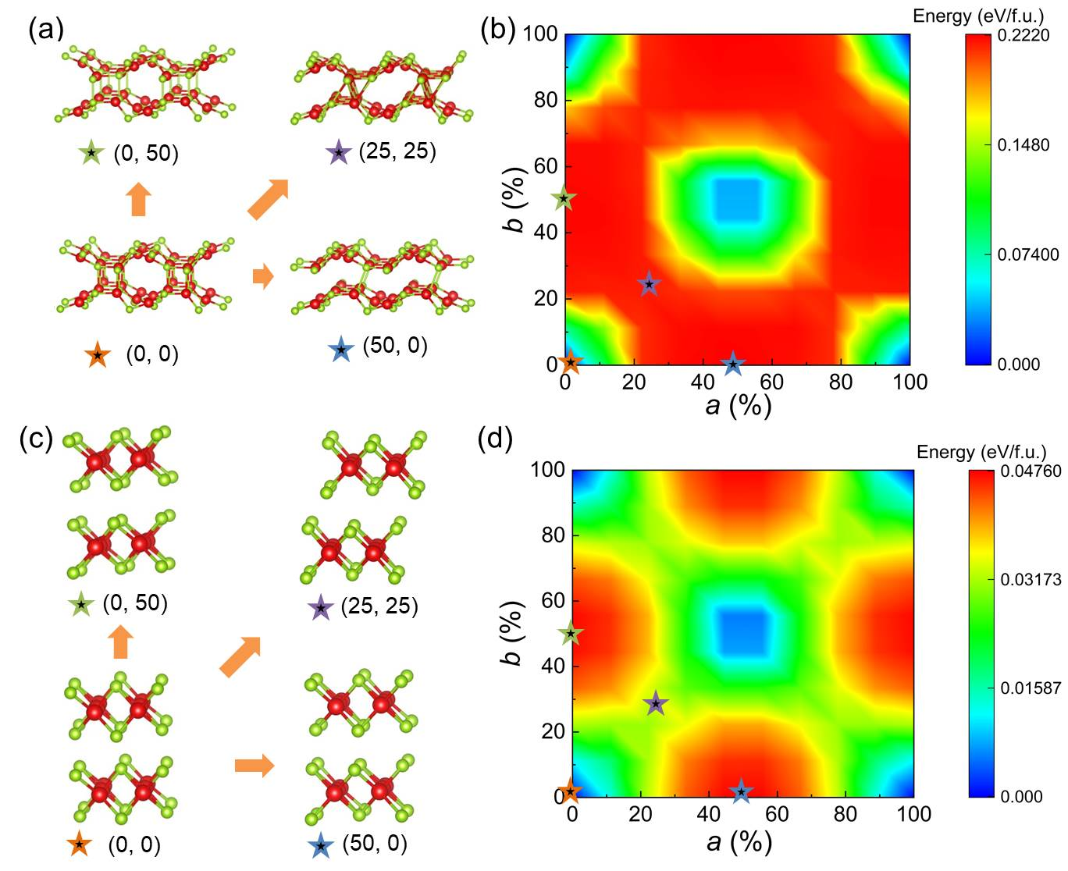
Fig. S1. The structural and energy diagrams of interlayer gliding of (a)-(b) wz monolayers and (c)-(d) CS structures.

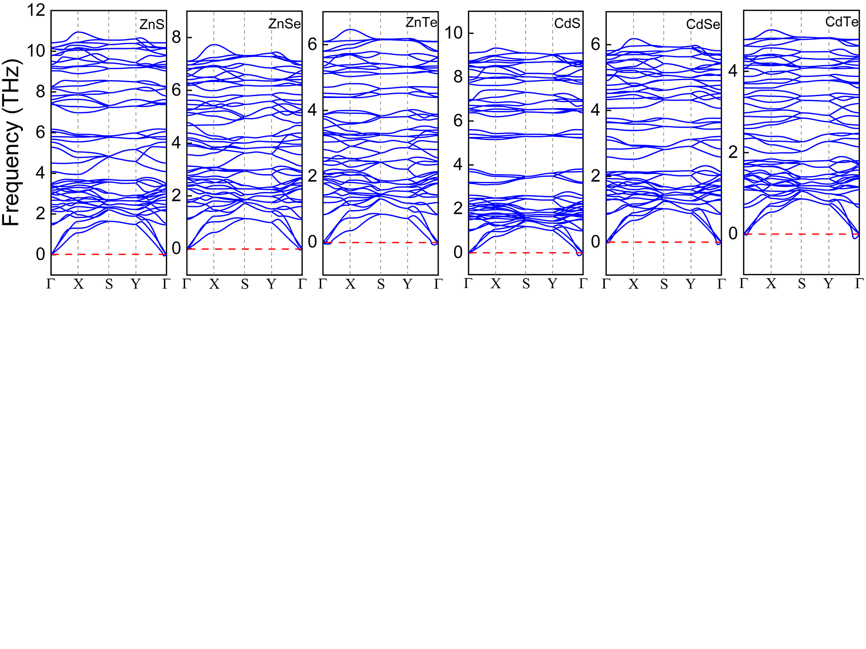 Fig. S2. Phonon spectrums in the whole Brillouin zone for the 2D AFE wz crystals.

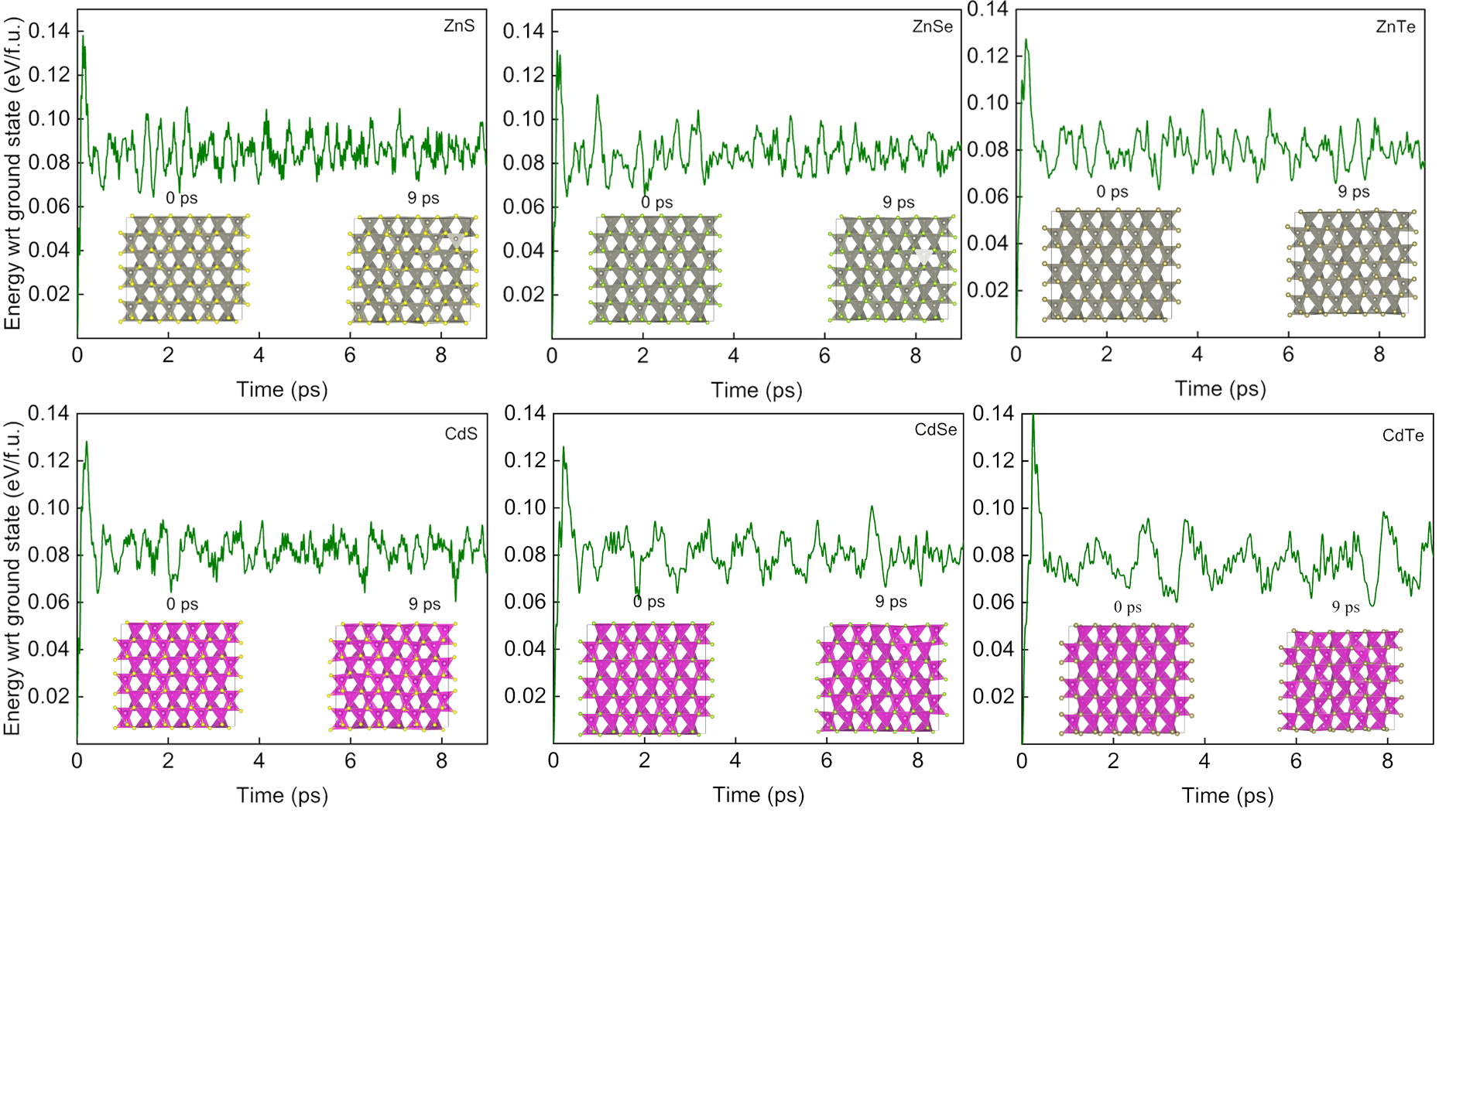
Fig. S3. AIMD global optimization (0-9 ps) for the 2D AFE wz materials, indicating stable structure without phase change.

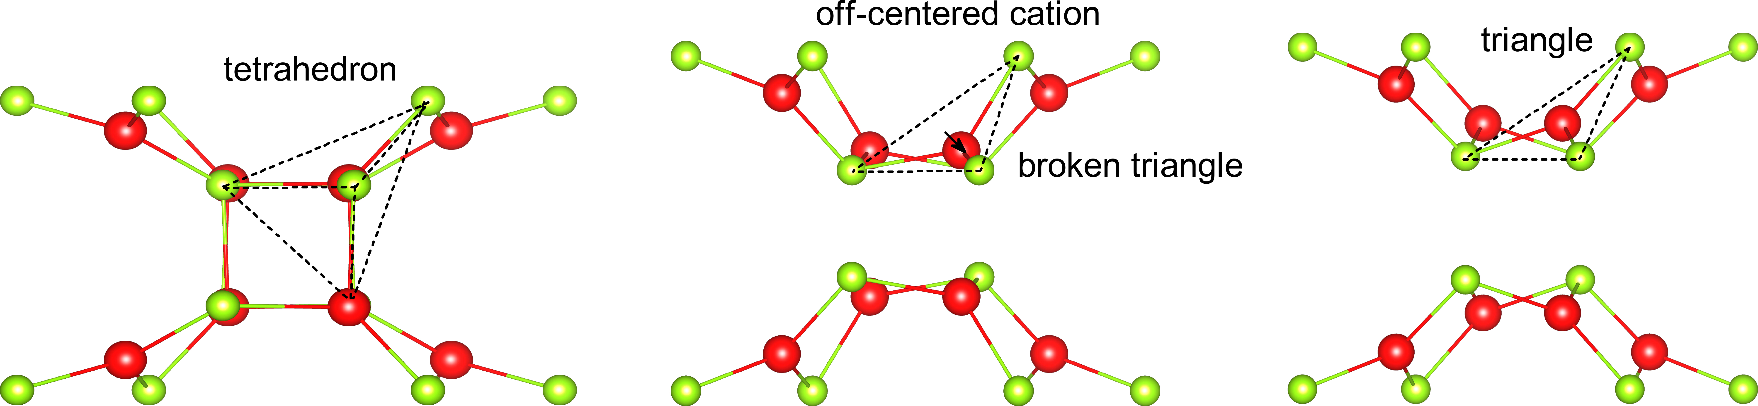
Fig. S4. Structural evolution for the interface atomic arrangement from broken tetrahedra to triangle.

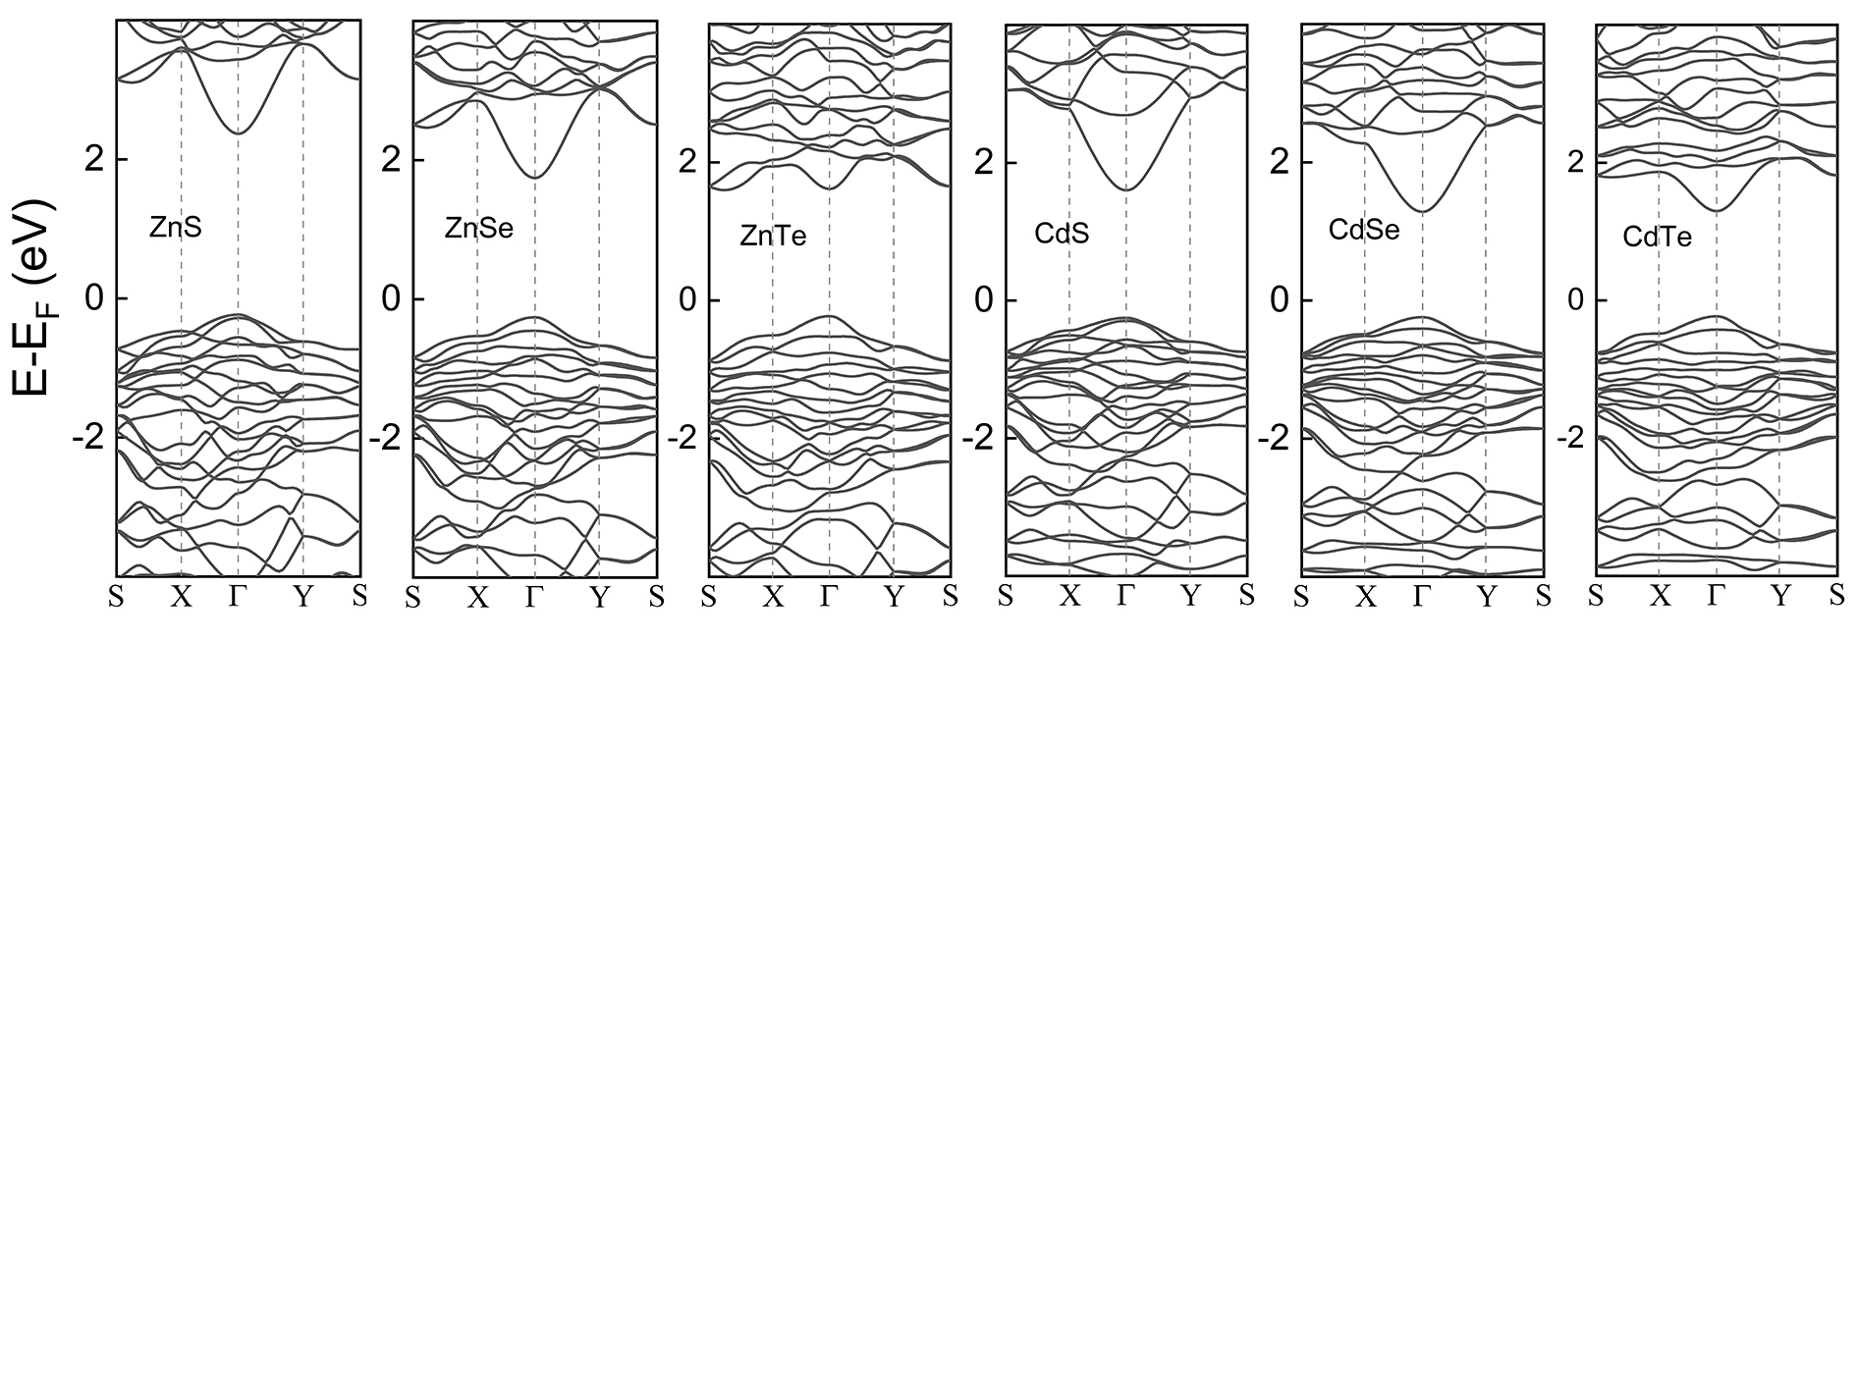
Fig. S5. Electronic band structures with PBE+SOC for the 2D AFE wz materials.

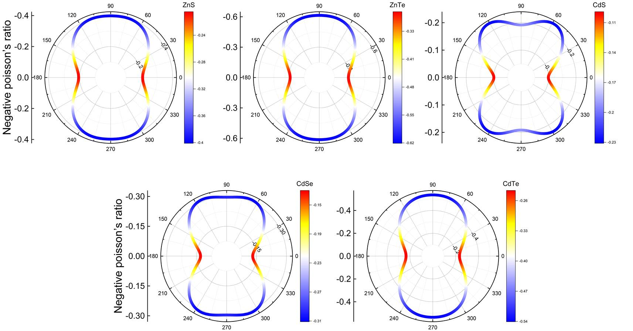
Fig. S6. Poisson’s ratio ν(θ) of the 2D AFE wz materials. Here, θ is the angle with respect to the a direction.

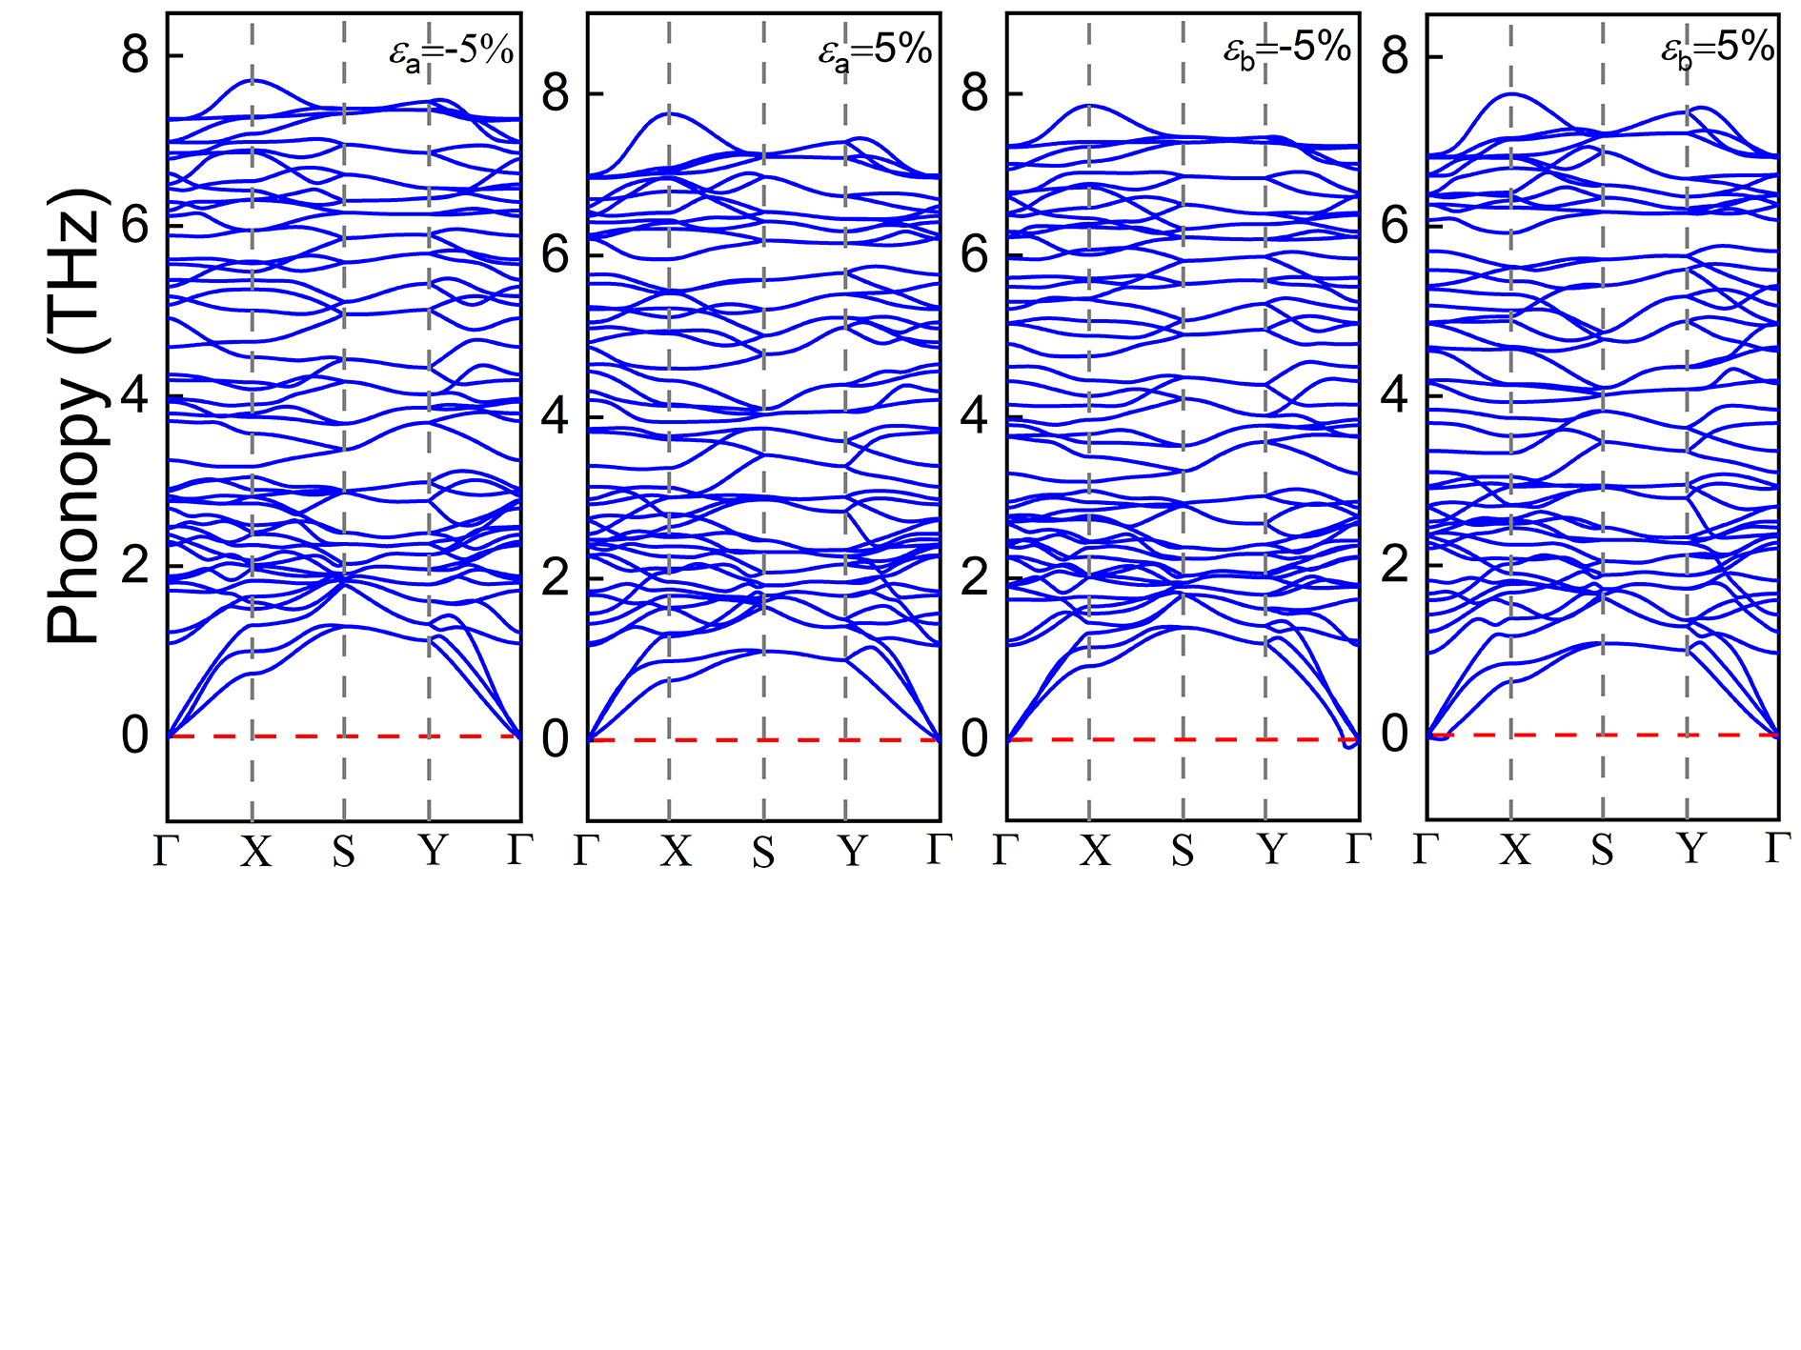
Fig. S7. Phonon spectrums in the whole Brillouin zone for the 2D AFE ZnSe with a wide strain range.

References
[1] Kohn W and Sham L J. Self-consistent equations including exchange and correlation effects. Phys Rev, 1965, 140(4A), A1133
[2] Kresse G and Joubert D. From ultrasoft pseudopotentials to the projector augmented-wave method. Phys Rev B, 1999, 59(3), 1758
[3] Kresse G and Furthmüller J. Efficiency of ab-initio total energy calculations for metals and semiconductors using a plane-wave basis set. Comput Mater Sci, 1996, 6(1), 15
[4] Perdew J P, Burke K and Ernzerhof M. Generalized gradient approximation made simple. Phys Rev Lett, 1996, 77(18), 3865
[5] Heyd J, Scuseria G E and Ernzerhof M. Hybrid functionals based on a screened Coulomb potential. J Chem Phys, 2003, 118(18), 8207
[6] Paier J, Marsman M, Hummer K, et al. Screened hybrid density functionals applied to solids. J Chem Phys, 2006, 124(15),
[7] Henkelman G, Uberuaga B P and Jónsson H. A climbing image nudged elastic band method for finding saddle points and minimum energy paths. J Chem Phys, 2000, 113(22), 9901
[8] Dronskowski R and Blöchl P E. Crystal orbital Hamilton populations (COHP): energy-resolved visualization of chemical bonding in solids based on density-functional calculations. J Phys Chem, 1993, 97(33), 8617
[9] Momma K and Izumi F. VESTA 3 for three-dimensional visualization of crystal, volumetric and morphology data. J Appl Crystallogr, 2011, 44(6), 1272
[10] Wang V, Xu N, Liu J-C, et al. VASPKIT: A user-friendly interface facilitating high-throughput computing and analysis using VASP code. Comput Phys Commun, 2021, 267, 108033
[11] Martyna G J, Klein M L and Tuckerman M. Nosé–Hoover chains: The canonical ensemble via continuous dynamics. J Chem Phys, 1992, 97(4), 2635
[12] Togo A and Tanaka I. First principles phonon calculations in materials science. Scr Mater, 2015, 108, 1
[13] Zhang H, Li Y, Hou J, et al. Dirac state in the FeB₂ monolayer with graphene-like boron sheet. Nano Lett, 2016, 16(10), 6124
[14] Shao Y, Shao M, Kawazoe Y, et al. Exploring new two-dimensional monolayers: pentagonal transition metal borides/carbides (penta-TMB/Cs). J Mater Chem A, 2018, 6(22), 10226
[15] Xiao C, Wang F, Yang S A, et al. Elemental ferroelectricity and antiferroelectricity in Group-V monolayer. Adv Funct Mater, 2018, 28(17), 1707383
[16] Ding J, Shao D-F, Li M, et al. Two-dimensional antiferroelectric tunnel junction. Phys Rev Lett, 2021, 126(5), 057601
[17] Noor-A-Alam M and Shin Y-H. Switchable polarization in an unzipped graphene oxide monolayer. Phys Chem Chem Phys, 2016, 18(30), 20443
[18] Li C, Zhai W, Li Y, et al. Extremely flat band in antiferroelectric bilayer α-In₂Se₃ with large twist-angle. New J Phys, 2021, 23(8), 083019
[19] Ding J, Wen L, Chai W, et al. Stacking induced nonvolatile tuning of band gap in bilayer In₂Se₃. Appl Surf Sci, 2021, 567, 150871
[20] Xu C, Chen Y, Cai X, et al. Two-dimensional antiferroelectricity in nanostripe-ordered In₂Se₃. Phys Rev Lett, 2020, 125(4), 047601
[21] Jia Y, Zhao M, Gou G, et al. Niobium oxide dihalides NbOX₂: a new family of two-dimensional van der Waals layered materials with intrinsic ferroelectricity and antiferroelectricity. Nanoscale Horiz, 2019, 4(5), 1113
[22] Guan Z, Zhao Y, Wang X, et al. Electric-field-induced room-temperature antiferroelectric–ferroelectric phase transition in van der Waals layered GeSe. ACS nano, 2022, 16(1), 1308
[23] Wu Z, Liu X, Ji C, et al. Discovery of an above-room-temperature antiferroelectric in two-dimensional hybrid perovskite. J Am Chem Soc, 2019, 141(9), 3812
[24] Han S, Liu X, Liu Y, et al. High-temperature antiferroelectric of lead iodide hybrid perovskites. J Am Chem Soc, 2019, 141(32), 12470
[25] Li M, Han S, Liu Y, et al. Soft perovskite-type antiferroelectric with giant electrocaloric strength near room temperature. J Am Chem Soc, 2020, 142(49), 20744
[26] Guan S and Luo J-W. Electrically switchable hidden spin polarization in antiferroelectric crystals. Phys Rev B, 2020, 102(18), 184104
[27] Zhao J, Wang X, Chen H, et al. Two-Dimensional Ferroelectric Ga₂O₃ Bilayers with Unusual Strain-Engineered Interlayer Interactions. Chem Mater, 2022, 34(8), 3648
[28] Chen S, Sun H, Ding J, et al. Unconventional distortion induced two-dimensional multiferroicity in a CrO₃ monolayer. Nanoscale, 2021, 13(30), 13048
[29] Dziaugys A, Kelley K, Brehm J A, et al. Piezoelectric domain walls in van der Waals antiferroelectric CuInP₂Se₆. Nat Commun, 2020, 11(1), 3623

